EXP:08 Library Management System

AIM:
To create a library management system using JSP and SQL Connector.

CODE:
library_managemet_system.jsp
<%@ page import="java.sql.*" %>
<%@ page contentType="text/html;charset=UTF-8" language="java" %>
<html>
<head>
<title>Library Management - Add Book</title>
<style>
body {
font-family: Arial, sans-serif;
background-color: #f3f3f3;
margin: 20px;
padding: 20px;
}

h2 {
color: #333;
}

form {
background-color: #fff;
padding: 20px;
border-radius: 8px;
box-shadow: 0 2px 5px rgba(0,0,0,0.1);
width: 400px;
}

input[type="text"],
input[type="number"],
select {
width: 100%;
padding: 8px;
margin: 6px 0 12px 0;
border: 1px solid #ccc;
border-radius: 4px;
}

input[type="submit"] {
background-color: #4CAF50;
color: white;
border: none;
padding: 10px 16px;
cursor: pointer;
border-radius: 4px;
}

input[type="submit"]:hover {
background-color: #45a049;
}

p {
font-size: 16px;
}

a {
color: #007BFF;
text-decoration: none;
}

a:hover {
text-decoration: underline;
}
</style>

<script>

function validateForm() {
const bookId = document.getElementById("bookId").value.trim();
const title = document.getElementById("title").value.trim();
const author = document.getElementById("author").value.trim();
const year = document.getElementById("year").value.trim();
const category = document.getElementById("category").value;
const copies = document.getElementById("copies").value.trim();
const currentYear = new Date().getFullYear();

if (!/^[a-zA-Z0-9]+$/.test(bookId)) {
alert("Book ID must be alphanumeric.");
return false;
}
if (!/^[A-Za-z ]+$/.test(title)) {
alert("Title must contain only letters.");
return false;
}
if (!/^[A-Za-z ]+$/.test(author)) {
alert("Author name must contain only letters.");
return false;
}
if (!/^\d{4}$/.test(year) || parseInt(year) > currentYear) {
alert("Year must be a valid 4-digit year.");
return false;
}

if (category === "") {
alert("Please select a category.");
return false;
}
if (isNaN(copies) || parseInt(copies) <= 0) {
alert("Copies must be a positive number.");
return false;
}

return true;
}
</script>
</head>
<body>
<h2>Add Book to Library</h2>
<form method="post" onsubmit="return validateForm()">
Book ID: <input type="text" name="bookId" id="bookId"/><br/>
Title: <input type="text" name="title" id="title"/><br/>
Author: <input type="text" name="author" id="author"/><br/>
Year: <input type="text" name="year" id="year"/><br/>
Category:
<select name="category" id="category">
<option value="">--Select--</option>
<option value="Science">Science</option>
<option value="Fiction">Fiction</option>
<option value="History">History</option>
</select><br/>
Copies: <input type="number" name="copies" id="copies"/><br/><br/>
<input type="submit" value="Add Book"/>

<p>
<label>Book Details:-</label>
<a href="./display_books.jsp">Click Here</a>
</p>
</form>

<%

// JSP Database logic

// TODO:Change password before run the code
// TODO: CREATE THE TABLE IN MYSQL
/**
CREATE TABLE books (
book_id VARCHAR(20) PRIMARY KEY,
title VARCHAR(100),
author VARCHAR(100),
year INT,
category VARCHAR(50),
copies INT
);
**/

String bookId = request.getParameter("bookId");
if (bookId != null) {
String title = request.getParameter("title");
String author = request.getParameter("author");
String year = request.getParameter("year");
String isbn = request.getParameter("isbn");
String category = request.getParameter("category");
String copies = request.getParameter("copies");

try {
Class.forName("com.mysql.cj.jdbc.Driver");
Connection conn = DriverManager.getConnection(
"jdbc:mysql://localhost:3306/library_management", "root", "");
PreparedStatement ps = conn.prepareStatement(
"INSERT INTO books (book_id, title, author, year, category, copies) VALUES (?, ?, ?, ?, ?, ?)");
ps.setString(1, bookId);
ps.setString(2, title);
ps.setString(3, author);
ps.setInt(4, Integer.parseInt(year));
ps.setString(5, category);
ps.setInt(6, Integer.parseInt(copies));

int result = ps.executeUpdate();
if (result > 0) {
%>
<script>alert("Book Added Successfully!!")</script>
<%
} else {
%>
<script>alert("Failed to add book!!")</script>
<%
out.println("<p style='color:red;'>Failed to add book.</p>");
}

ps.close();
conn.close();
} catch (Exception e) {
out.println("<p style='color:red;'>Error: " + e.getMessage() + "</p>");
}
}
%>
</body>
</html>
OUTPUT:

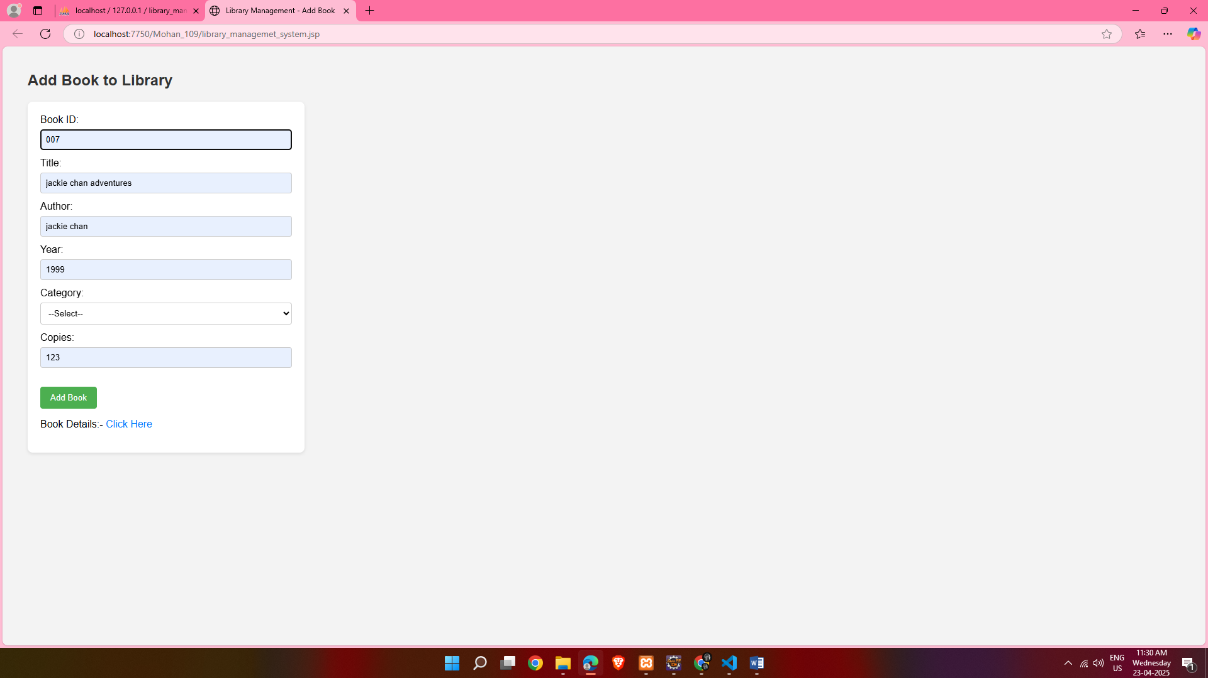

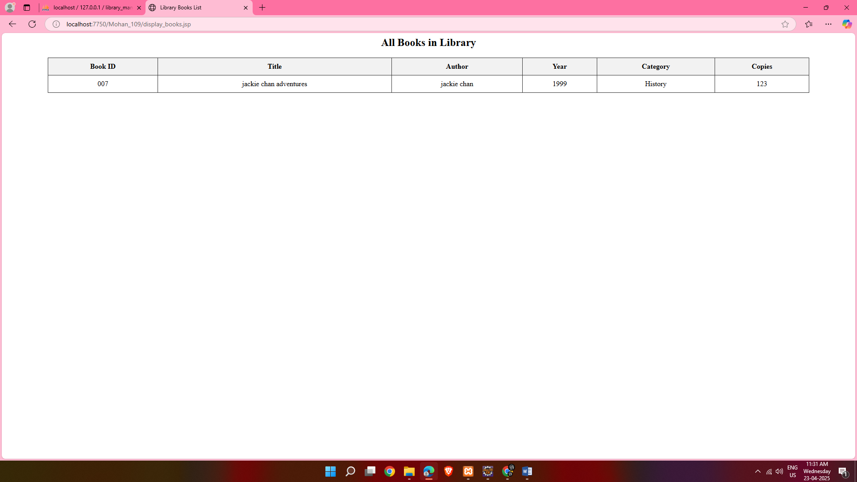

RESULT:
creation a library management system using JSP and SQL Connector is done successfully

